STRATEGIC REPORT: DAY 3 - GEOSPATIAL INTELLIGENCE
Project: 2026 Electoral Analysis
Status: Completed (Visualization Phase)

1. Executive Summary
Day 3 focused on transforming categorized data into actionable geographic intelligence. By mapping the 156 "Battleground Counties," we identified specific Geospatial Clusters where the election will be won or lost. The data shows that electoral volatility is not random but geographically anchored in key regional hubs.

2. Key Visual Insights
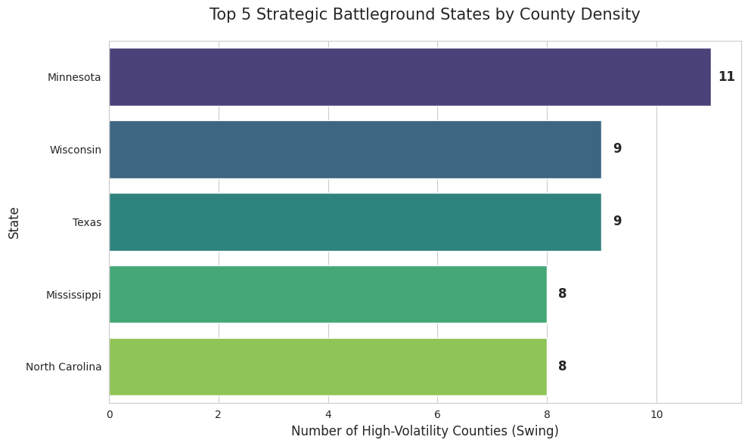
- The Upper Midwest Hub: Minnesota (11 counties) and Wisconsin (9 counties) emerge as the primary strategic corridor. Their high density of swing counties indicates a shared regional sensitivity to current economic indicators.
- Southern Volatility: The emergence of 9 critical counties in Texas highlights a significant shift in suburban/urban margins, offering a strategic opening in traditionally non-competitive zones.
State | Swing Counties | Strategic Priority
Minnesota | 11 | Critical / High
Wisconsin | 9 | Critical / High
Texas | 9 | Emerging
Mississippi | 8 | Targeted
North Carolina | 8 | Consolidated

3. Strategic Recommendation
Transition to a "Cluster-First" Deployment Model. Marketing and operational budgets should be geo-fenced around the identified high-density clusters in the North and the South to maximize "Impact per Dollar".
